Sphere.obj

Planar texture mapping

Cylindrical texture mapping

Spherical texture mapping

Bunny.obj

Planar texture mapping

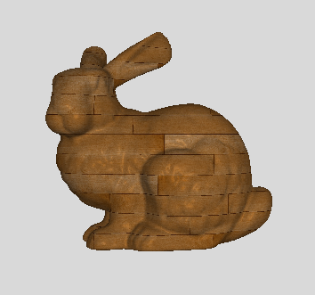

Cylindrical texture mapping

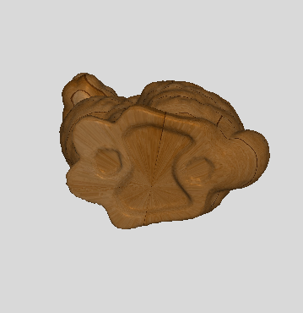

Spherical texture mapping

